

**Orient HBU-36HH03**

**Rs. 188,000/-**

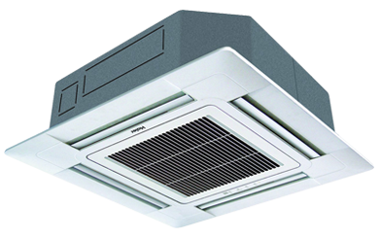

**Product Features**

* wide voltage
* active PFC technology
* more luxury to your living room
* anti dust
* 24 hours timer

**Specification**

**Type** Ceiling Cassette AC

**Cooling (Btu/h)** 38000

**Voltage (V)** 220-240

**Power Input (W)** 4200

**EER (Btu/W-h-W/W)** 6.1-3.7